6.NS.1

SELECTED RESPONSE
Select the correct answer.
1. You have cup of sour cream to make tacos. If each taco requires 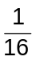 cup of sour cream, how many tacos can you make?
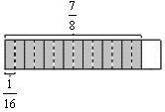
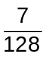 taco 14 tacos
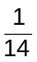 taco 15 tacos
2. How many -cup servings are there in cup of peanut butter?

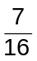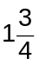
3. Carl wants to plant a garden that is
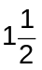 yards long and has an area of
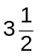 square yards. How wide should the garden be?
yard 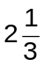 yards
2 yards 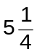yards
4. Divide. 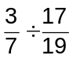
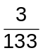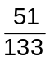
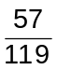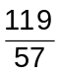
5. Nima uses cup peanuts, cup cashews,  cup pecans, and some raisins in a recipe that makes 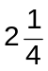 cups of trail mix. How many cups of peanuts are there per cup of trail mix?
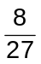
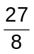
6. Jerry is tiling the wall behind his sink. The tiles he’s using are square with sides that measure inches. If the area of wall he’s tiling is 42 inches long and 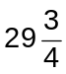 inches high, how many tiles will he need?
17
24
408
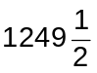
CONSTRUCTED RESPONSE
7. The following division is being performed using multiplication by the reciprocal. Find the missing numbers.
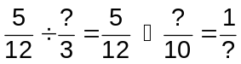

8. Ida is cutting a 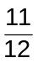-foot wooden board into 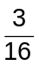-foot sections to do some detail work on a model she is building. How many whole -foot sections are there in the -foot wooden board? Explain your answer and show your work.

9. Baruka has gallon of milk left in the fridge.
a. How many 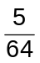-gallon (10-ounce) servings of milk does she have left? Show your work.

b. If she drinks 10 ounces of milk a day, how many days of milk does she have left? Explain.

10. Juan was presented with the following problem on a math test: “Divide by . Show your work.” His work is shown below. What was Juan’s error? Correct his work and state the correct quotient.
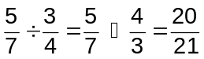

11. Consider the division statement 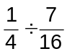.
a. Describe a real world situation that might involve this expression.

b. Find the quotient.

c. Interpret the quotient in terms of the situation you described in part a.

6.NS.2

SELECTED RESPONSE
Select the correct answer.
1. Divide. 196 ÷ 28
6
6 R27
7 R1
7
2. Divide. 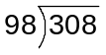
3
3 R14
4
14 R3
3. An art teacher has 192 containers of paint for 17 students. If the teacher wants to provide each student with an equal number of containers, how many containers will be left over?
0
5
7
18
4. A local theater can seat 2,254 people. The seats are arranged into 98 rows. Each row has the same number of seats. How many seats are there in each row?
15 23
20 32
Select all correct answers.
5. The event staff for a local concert hall has 73 tickets to sell. If they sell all of the tickets at the same price, they will have $438. Which of the following people have enough money to buy a ticket?
Celia has $4.50.
Louis has $7.00.
Jan has $6.50.
Nicola has $6.00.
Chuck has $5.00.
CONSTRUCTED RESPONSE
6. A skyscraper with 102 floors is 1,326 feet tall. Each floor is the same height. How tall is each floor? Show your work.

7. An apple orchard harvested 3,584 apples and separated them evenly into
112 bags.
a. How many apples are in each bag?

b. If 56 apples were placed in each bag instead, how many bags would be left over?

8. A movie streaming service charges its customers $15 a month. Martina has $98 saved up. Will she have any money left over if she pays for the maximum amount of months she can afford? Explain.

9. Maurice says that 1079 ÷ 62 is 16 with a remainder of 87.
a. Without seeing his work, how can you tell Maurice divided incorrectly?

b. Maurice is correct about this fact:
16 × 62  87  1079. Explain how you can use that fact to find the correct quotient and remainder for 1079 ÷ 62 without actually dividing. Then find the quotient.

10. The administrator of the school is dividing 342 students into 38 groups to do a team-building exercise. One of the guidance counselors says that the exercise will be most effective if there are 7 or fewer students in a group.
a. Explain why the administrator’s plan is not as effective as it can be.

b. How many groups should there be? Will all the groups have the same number of students? Explain.

11. a. Find 117 ÷ 13, 118 ÷ 13, and
119 ÷ 13.

b. Without dividing, what is the quotient of 120 ÷ 13? Use the pattern you found in the first three problems to explain you answer.

c. According to the pattern, 130 ÷ 13 should be 9 with a remainder of 13. Explain why that is incorrect and find the correct quotient.

6.NS.3

SELECTED RESPONSE
Select the correct answer.
1. Add. 13.389  1.24
13.513
14.529
14.62
14.629
2. Subtract. 102.596  10.478
92.118
92.128
112.122
192.118
3. Multiply. 1.8762  4.2
7.88004
78.8004
788.004
7,880.04
4. Divide. 0.09975  0.007
1.425
14.25
142.5
1,425

Match each multiplication expression with its product.

5. 2.986 × 1.26
6. 0.2986 × 0.126
7. 29.86 × 12.6
8. 298.6 × 126
9. 2.986 × 12.6
10. 2,986 × 126
11. 298.6 × 12.6
12. 2.986 × 0.126
A 376,236
B 37,623.6
C 3,762.36
D 376.236
E 37.6236
F 3.76236
G 0.376236
H 0.0376236

CONSTRUCTED RESPONSE
13. Elsa has $45.78 in her savings account and $21.38 in her wallet.
a. How much money does Elsa have?

b. If Elsa puts half of the money in her wallet in the bank, how much money will she have in her savings account?

14. Mariposa needs a number of 0.3125-inch strips of wood for a model she is building. How many of these strips can she get from a 5.625-inch wooden board? Show your work.

15. Jean-Paul incorrectly states that
4.2874  1.286  4.416. His work is shown below. Explain Jean-Paul’s mistake and correct his work.
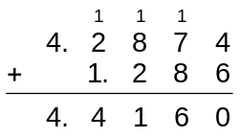

16. At a local gas station, regular gasoline sells for $3.499 per gallon, while premium gasoline sells for $3.879 per gallon.
a. Find the difference in price between the two types of gasoline.

b. How much does a person save on 15.25 gallons of gas by buying regular instead of premium? Show your work, and round your answer to the nearest whole cent.

17. Shen earns $9.60 per hour at his
part-time job. Last month, he worked
7.25 hours the first week, 8.75 hours the second week, 5.5 hours the third week, and 6.75 hours the fourth week. Shen puts half of his paycheck in the bank every other week starting with the first.
a. How much money did Shen earn each week?

b. How much money did he have in the bank at the end of last month? Show your work.

c. How much money did Shen have to spend from his 4 paychecks? Show your work.

18. Pablo wants to buy a steak at the grocery store. He has two options. The first is 1.37 pounds and costs $9.59. The second is 1.75 pounds and costs $10.85. Which is the better buy? Explain.

6.NS.4

SELECTED RESPONSE
Select the correct answer.
1. Find the greatest common factor of
12 and 18.
1
2
3
6
2. Find the least common multiple of
8 and 10.
32
40
50
80
3. Find the greatest common factor of
7 and 11.
1
7
11
77
4. Find the least common multiple of 6
and 12.
6
12
24
72
5. Factor out the greatest common factor of the expression below using the distributive property.
90  60
30(3  2)
10(9  6)
15(6  4)
6(15  10)
CONSTRUCTED RESPONSE
6. Is it possible to use the distributive property to rewrite 85  99 as a product of a whole number greater than 1 and a sum of two whole numbers? Explain your answer.

7. Charlie and Dasha are roommates, and they have a dog. If neither of them is home, they hire someone to watch the dog. Charlie must go on business trips every 6 months, while Dasha must go on business trips every 9 months. If they both just got back from business trips, how many months will it be before they need to hire someone to look after the dog again? Explain your answer.

8. Salvatore is making some party favors for his birthday party. He has 96 pencils and 80 boxes of raisins. He wants each party favor to be the same, and he wants to use all of the pencils and raisins. Find the GCF of 96 and 80 to figure out how many party favors he can make. How many pencils and boxes of raisins will be in each one?

9. a. What is the LCM of two numbers when one number is a multiple of the other? Give an example.

b. What is the LCM of two numbers that have no common factors greater than 1? Give an example.

10. a. Find the greatest common factor of
3 and 5.

b. Find the greatest common factor of 11 and 13.

c. Use your results from parts a and b to make a conjecture about the GCF of any pair of prime numbers.

11. Consider the sum 36  45.
a. Use the distributive property to rewrite the sum as the product of a whole number other than 1 and a sum of two whole numbers.

b. Write the sum as the product of a whole number different from the one you chose in part a and a sum of two whole numbers.

c. Can this be done in more than two ways? Explain.

12. A baker has 72 vanilla cupcakes and
80 chocolate cupcakes. She wants to make platters for a party that have both kinds of cupcakes and the same total number of cupcakes on each platter.
a. Can the baker make 10 platters of cupcakes with no cupcakes left over? Explain why or why not.

b. What is the greatest number of platters she can make? How many of each kind of cupcake will be on each platter?

6.NS.5

SELECTED RESPONSE
Select the correct answer.
1. Carlos deposited $28.50 into his bank account after making a $20.00 withdrawal to pay for some school supplies. Represent these situations as signed numbers.
28.50, 20.00
28.50, 20.00
28.50, 20.00
28.50, 20.00
2. In Barrow, Alaska, the northernmost town in the United States, the record high temperature is 79 F, recorded on
July 13, 1993. The record low is 56 F below zero, recorded on February 3, 1924. Represent these situations as signed numbers.
79, 56
79, 56
79, 56
79, 56
3. While on vacation in Australia, Brent and Giselle decide to explore the Great Barrier Reef. Brent decides to go snorkeling near the surface at a depth of 5 feet below sea level. Giselle is an experienced scuba diver and decides to explore a little deeper at 80 feet below sea level. Represent these situations as signed numbers.
5, 80
5, 80
5, 80
5, 80
Select all correct answers.
4. Choose all the situations that can be described with a negative number.
The Titanic rests at a depth of about 12,000 feet.
The temperature of the photosphere of the Sun is approximately 5,505 C.
The height of the Taipei 101 skyscraper in Taiwan is 1,671 feet.
The average high temperature in Antarctica in January is 15 F below zero.
The world record for deepest scuba dive is 1,083 feet.
The world record for highest base jump from a building is 2,205 feet above sea level.
CONSTRUCTED RESPONSE
5. An object’s elevation is its height above some fixed point. The most commonly used point is sea level. The word “altitude” is used to describe an object’s position above sea level, whereas the word “depth” is used to describe an object’s position below sea level. Express each of the following situations as a signed number or zero.
a. An airplane at an altitude of 30,000 feet

b. A submarine at a depth of 1,200 feet

c. A boat on the surface of the ocean

6. In golf, par is the number of strokes an average player should need to complete a particular hole. If a golfer scores under par, the score is reported as a negative number representing the number of strokes less than par. If a golfer scores over par, the score is reported as a positive number. Scoring par exactly is represented by 0. Express each of the following scores as a signed number
or zero.
a. Margaret completed 18 holes with an overall score of 9 under par.

b. Anika completed the last hole with a score of 1 over par.

c. Johan completed 9 holes on par.

d. Seamus completed the first hole of the tournament with a score of 2 under par.

7. In a standard savings account, the term “credit” is used to describe a deposit of money into the account. The term “debit” is used to describe a withdrawal of money from the account. Describe what a positive number, a negative number, and zero mean in this context.

8. Use a signed number to represent each of the following situations. Then describe what 0 represents in the same situation.
a. Salazar dives to a depth of 73 feet.

b. Nu deposits $16.78 into her bank account.

c. Overnight, the temperature drops by 15 F.

9. Write two situations that could be described by each of the following numbers.
a. 50

b. 50

6.NS.6a, 6.NS.6b

SELECTED RESPONSE
Select the correct answer.
1. Describe the locations of 3 and 3 with respect to 0 on a number line.
3 is to the right of 0, and 3 is to the right of 0.
3 is to the left of 0, and 3 is to the left of 0.
3 is to the left of 0, and 3 is to the right of 0.
3 is to the right of 0, and 3 is to the left of 0.
2. What is the opposite of 12?
12
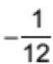
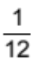
12
3. In which quadrant is 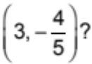
Quadrant I
Quadrant II
Quadrant III
Quadrant IV
4. If the point (1.9, 2) is reflected across the x-axis, which quadrant will it be in?
Quadrant I
Quadrant II
Quadrant III
Quadrant IV
5. Choose the correct sign description of a point in Quadrant I.
(, )
(, )
(, )
(, )
Select all correct answers.
6. Which pairs of numbers lie on opposite sides of 0 on a number line?
8, 7
10, 10
4, 9
8, 15
21, 21
2, 200
CONSTRUCTED RESPONSE
7. Graph 5, 0, 2, and 4 on the number line. Then, graph their opposites on the same number line.
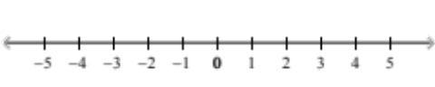
8. Elevation is measured as a distance above or below sea level. Sea level has an elevation of 0 feet. Johanna is standing on a hillside 35 feet above sea level, and Marcus is exploring a cave at an elevation that is the opposite of Johanna’s elevation. What is Marcus’s elevation?

9. The point (1.235, 987) is in Quadrant IV. What kind of reflection would move this point from Quadrant IV to Quadrant III? Which coordinate(s) would change signs?

10. To celebrate the 100th anniversary of the opening of their school, the teachers organize a treasure hunt for the students. One of the clues states, “Think of the main office as 0 on a number line. You will find the next clue in the room that is the opposite of the teachers’ lounge.” Use the diagram below to determine where the students should go to find the next clue. Explain.
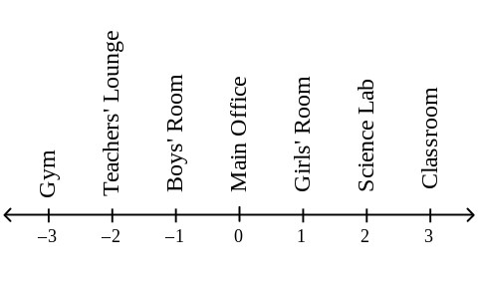

11. a. Find the opposites of 8, 1, and 7.

b. Find the opposites of the opposites from part a.

c. What do you notice about a number and the opposite of its opposite?

12. Consider the ordered pair 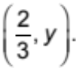 Find a value of y that places the ordered pair in each quadrant. If it is not possible for the ordered pair to be in a certain quadrant, explain why.

13. The following graph shows the point
(4, 3). It also shows the points that result when (4, 3) is reflected across the x-axis and the y-axis.
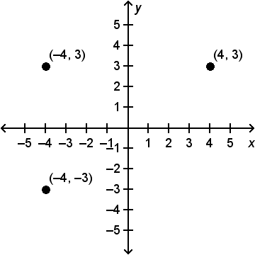
a. The point (4, 3) reflected across the x-axis is (4, 3). What do you notice about the signs of the coordinates?

b. The point (4, 3) reflected across the y-axis is (4, 3). What do you notice about the signs of the coordinates?

c. What do you think would happen to the signs of the coordinates of
(4, 3) if it were reflected across the x-axis and then the result was reflected across the y-axis? Explain your answer and provide the resulting point.

6.NS.6c

SELECTED RESPONSE
Select the correct answer.
1. Where is on a number line?
Between 3 and 2
Between 1 and 0
Between 0 and 1
Between 2 and 3
2. Identify the point on the number line.
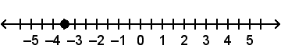
4
3.5
3.5
4
3. Identify the coordinates of the point.
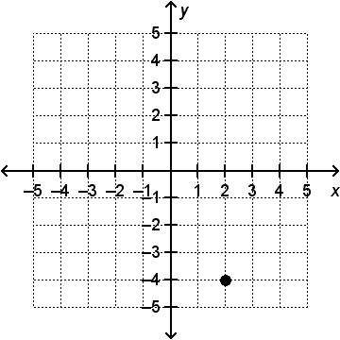
(2, 4)
(4, 2)
(4, 2)
(2, 4)
4. Describe the process of graphing 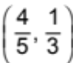 on a coordinate plane.
Starting at the origin, move 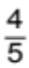 unit in the positive x-direction. Then, move unit in the positive y-direction.
Starting at the origin, move unit in the negative x-direction. Then, move unit in the negative y-direction.
Starting at the origin, move unit in the positive x-direction. Then, move unit in the negative y-direction.
Starting at the origin, move unit in the negative x-direction. Then, move unit in the positive y-direction.
Select all correct answers.
5. What numbers are graphed on the vertical number line?
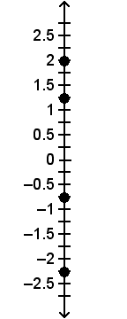
2.5 1
2.25 1.25
1.75 2
0.75 2.5

CONSTRUCTED RESPONSE
6. Graph and label (0.75, 1.25), (1.5, 2), (0.25, 1.75), and (1, 0.75).
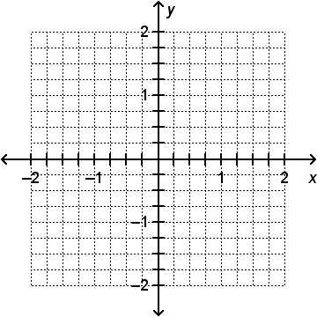
7. A group of students is participating in a tug-of-war contest. The rope is laid out in a straight line with a knot in the middle. The students are positioned according to the following diagram. The object of the game for both teams is to pull the knot
2 units in their direction. The first team to do so wins the contest. Assume that each team pulls in a straight line. If Holden’s side wins, find the final positions of Holden and Marishka. Explain your answers using a number line.
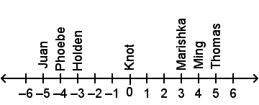

8. Below is a map showing various places in relation to Carlos’s house at the origin. Find the coordinates of the library,
the school, the bike shop, and the baseball field.
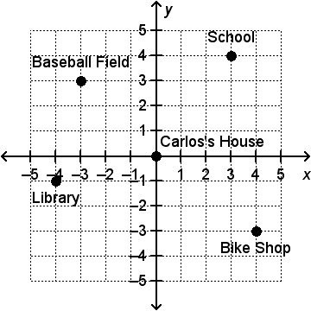

9. a. Graph and label the point (2, 8).
b. Find the point that represents a reflection of (2, 8) across the x-axis. Graph and label the result.
c. Find the point that represents a reflection of the result from part b across the y-axis. Graph and label the result.
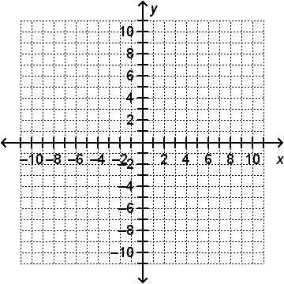

6.NS.7a

SELECTED RESPONSE
Select the correct answer.
1. If 3  7 and 1  7, where are 3 and
1 relative to 7 on a number line?
3 and 1 are both to the right of 7.
3 and 1 are both to the left of 7.
3 is to the right of 7 and 1 is to the left of 7.
3 is to the left of 7 and 1 is to the right of 7.
2. If 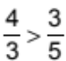 and 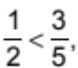 where are 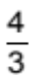 and  relative to 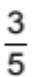 on a number line?
and are both to the right of 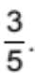
and are both to the left of
is to the right of , and is to the left of
is to the left of , and is to the right of
3. A number x is to the left of 10.2 on a number line. Which inequality describes this situation?
x  10.2
x  10.2
10.2  x
x  10.2
4. On a number line, a number p is to the right of 18. Which of the following choices describes this situation?
18  p p  18
18  p p  18
Select all correct answers.
5. Which statements are equivalent to the inequality 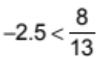?
2.5 is to the left of 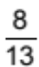 on a
number line.
is to the right of 2.5 on a number line.
is to the left of 2.5 on a
number line.
2.5 is less than .
2.5 is to the right of on a number line.
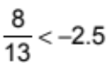
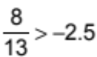
is less than 2.5.
CONSTRUCTED RESPONSE
6. Describe the positions of 10 and 17 relative to each other on a number line in two different ways, given that 17  10.

7. 0.001  x and x  10,000. Is x between 0.001 and 10,000, to the left of 0.001, or to the right of 10,000? Explain your reasoning.

8. Look at the following inequalities.
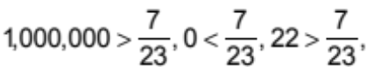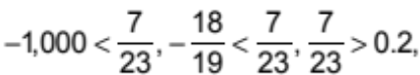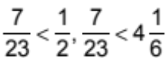
a. Which of the numbers above are to the right of 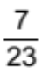 on a number line?

b. Which of the numbers above are to the left of on a number line?

9. Consider the three points on the
number line.
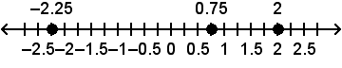
a. Pick any two of the points and write an inequality statement. Explain your answer using the positions of the two numbers relative to each other on the number line.

b. Could the relationship between the two numbers you chose be represented in a different way? If so, write the inequality.

10. Matthias says that the inequality 1  2.2 is true because 1 is to the right of 2.2 on a number line. Helga says that the inequality is true because 2.2 is to the left of 1 on a number line. Who is correct? Explain your answer by graphing 1 and 2.2 on a number line and interpreting the result.
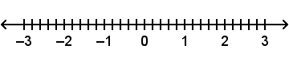

11. Consider the inequality 5.5  4.
a. Graph the two numbers on a
number line.
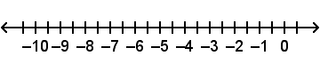
b. Describe the positions of 5.5 and
4 relative to each other on a number line in two different ways.

c. Write an inequality using 5.5 and a number to the left of 5.5 on the number line.

d. Write an inequality using 4 and a number to the right of 4 on the number line.

6.NS.7b

SELECTED RESPONSE
Select the correct answer.
1. The thermometer at Bruce’s house
shows a temperature of 2 F. The thermometer at Zan’s house reads
5 F. Which inequality represents this situation? Whose thermometer shows a warmer temperature?
2 F  5 F; Bruce’s thermometer shows a warmer temperature.
2 F  5 F; Zan’s thermometer shows a warmer temperature.
2 F  5 F; Bruce’s thermometer shows a warmer temperature.
2 F  5 °F; Zan’s thermometer shows a warmer temperature.
2. Marco and Randy decide to have a foot race on a local field. Marco can maintain a speed of 8 miles per hour, while Randy runs at 6 miles per hour. Which inequality represents this situation? Who is faster?
8 mph  6 mph; Marco is faster.
8 mph  6 mph; Randy is faster.
8 mph  6 mph; Marco is faster.
8 mph  6 mph; Randy is faster.
3. In a cooking class, each student needs
cup of sugar for a recipe. Zach has
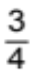 cup of sugar at his cooking station, while Suzanne has cup at her cooking station. Who has enough sugar to make the recipe?
Zach has enough sugar.
Suzanne has enough sugar.
Zach and Suzanne both have enough sugar.
Neither Zach nor Suzanne has enough sugar.
4. Anthony has $53.43 in his savings account, Maxine has $54.78, Rodolfo
has $54.98, and Nicola has $53.29. Who has saved the most money? Who has saved the least?
Maxine has saved the most money, and Anthony has saved the least.
Maxine has saved the most money, and Nicola has saved the least.
Rodolfo has saved the most money, and Nicola has saved the least.
Rodolfo has saved the most money, and Anthony has saved the least.
Select all correct answers.
5. Jack needs a piece of wood at least
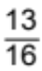 inch long for some detail work on a project he is working on. Which of the following lengths of wood would meet
his requirements?
inch
inch
inch
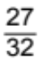 inch
inch
CONSTRUCTED RESPONSE
6. A recipe calls for cup strawberries,
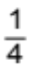 cup sugar, cup walnuts, and cup flour. Order the amounts from least to greatest. Which ingredient does the recipe require the least amount of?

7. While climbing a mountain, Chuck and Marissa decided to take separate trails and meet at the peak. Chuck took the easier trail and was at an elevation of about 425 feet after an hour. Marissa took the more advanced trail and made
it to 550 feet in an hour. Marissa started to get tired and was only able to climb 150 more feet in the next hour. Since Chuck took the easier trail, he was able to climb an additional 350 feet in the second hour. Write inequalities that express their locations on the mountain after 1 hour and after 2 hours. Who was at a higher elevation after 2 hours?

8. Sally plants four flowers in her garden and measures their heights (Height 1). One month later, she measures their heights again (Height 2). Which flower grew the most? Show your work.
Flower | Height 1 | Height 2
1 | 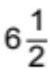 in. | 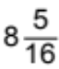 in.
2 | 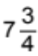 in. | 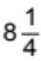 in.
3 | 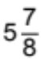 in. | 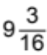 in.
4 | 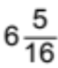 in. | 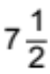 in.

9. The record low temperatures for three towns in Alaska are given in the table below. Write three inequalities using three different pairs of temperatures. Which of the three towns has the
highest record low?
Town | Record Low
Anchorage | 34 °F
Barrow | 56 °F
Juneau | 22 °F

10. Sam and Nima have part-time jobs for
the summer. Over the last three weeks, Sam has made deposits of $40.25, $58.50, and $28.40 into his savings account. During the same time, his sister Nima has deposited $60.85, $20.00, and $62.13 into her savings account.
a. Write an inequality that compares Sam’s total deposits with Nima’s
total deposits. Who deposited more money?

b. Sam and Nima both make withdrawals from their accounts. Nima withdraws $37.28. After the withdrawals, Sam has more money
in his account than Nima does.
What is the largest amount Sam could have withdrawn for this to be true? Explain your reasoning.

6.NS.7c, 6.NS.7d

SELECTED RESPONSE
Select the correct answer.
1. Marlene is about to write a check for $103.48 to pay for groceries. When she subtracts the amount of the check from her account balance, she sees that the new balance would be $28.80. Rather than overdraw her checking account, Marlene asks the cashier to remove some items. For Marlene to be able to pay by check without overdrawing her account, what is the minimum value of the items the cashier must remove?
$103.48
$28.80
$28.80
$103.48
2. Which of the following pairs of numbers have the same absolute value?
1, 0.1
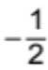,
0, 1
4, 40
3. How do the numbers 3 and 2 compare? How do their absolute values compare?
3 is greater than 2, but 2 has the greater absolute value.
2 is greater than 3, but 3 has the greater absolute value.
3 is greater than 2, and 3 has the greater absolute value.
2 is greater than 3, and 2 has the greater absolute value.
4. Which is greater, 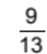 or 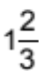? Which number has the greater absolute value?
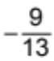 is greater than 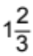, but has the greater absolute value.
is greater than , but has the greater absolute value.
is greater than , and has the greater absolute value.
is greater than , and has the greater absolute value.
Select all correct answers.
5. Which numbers have an absolute value of 2?
3
2
1
0
1
2
3
CONSTRUCTED RESPONSE
6. Identify the pairs of numbers on the number line that have the same
absolute value.
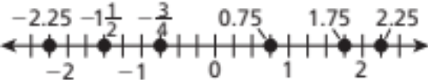

7. Both Vince and Betty use their debit cards to make purchases. After their purchases, Vince’s checking account balance shows a transaction of $25.00, while Betty’s shows $18.25. Who spent more money? Justify your answer by writing an inequality.

8. Find two numbers a and b with the following properties.
a. a  b, 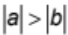

b. a  b, 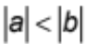

c. a  b, 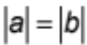

9. Monica is hiking in California’s Death Valley. Along her route, she sees a sign that says “282 feet below sea level.” Elevation is the height above or below
a fixed point. Positive elevations indicate heights above the point, and negative elevations indicate heights below
the point.
a. What is the elevation of the sign relative to sea level? Explain.

b. How far up or down must Monica hike from the sign to reach sea
level? Explain.

10. In a town, Talbot Street is the main commercial center. The number line shown represents Talbot Street, where each unit represents 100 feet.
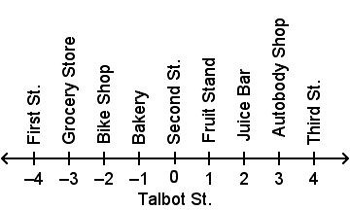
a. Yvette and Naomi are at the intersection of Second Street and Talbot Street. If Yvette goes to the grocery store and Naomi goes to the fruit stand, who travels farther from Second Street? Justify your answer.

b. Anzelm is at the intersection of First Street and Talbot Street. How many feet is Anzelm from Second Street? Justify your answer.

11. Suppose a and b are two negative numbers. If a  b, is it possible that
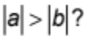 Explain your answer, using a number line and examples as needed.

6.NS.8

SELECTED RESPONSE
Select the correct answer.
1. On a coordinate plane, point A is located at (5, 3). To get to point B, move 8 units to the right, 6 units down, and 1 unit to the left. What are the coordinates of
point B?
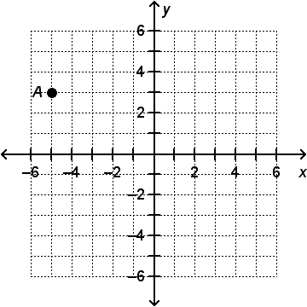
(12, 9)
(12, 3)
(2, 3)
(2, 9)
2. What is the distance between point A
at (7, 5) and point B at (2, 5)?
9
5
9
10
3. North is the positive y-direction on a coordinate plane, and 1 unit on the plane represents 1 foot. A soccer ball is kicked directly east from point (3, 4). The ball travels a horizontal distance of 23 feet through the air and rolls an extra 14 feet. Where does the ball stop?
(34, 4)
(40, 4)
(20, 4)
(11, 4)
CONSTRUCTED RESPONSE
4. Jerry and Meena are riding their bicycles through the city to meet at the park, as shown on the coordinate plane. On the coordinate plane, north is in the positive y-direction, and 1 unit represents 1 city block. Jerry starts at the point (2, 5)
and rides north toward the park at the point (2, 1). Meena starts at east of the park at the point (5, 1) and rides west toward the park. How far does each person travel to reach the park?
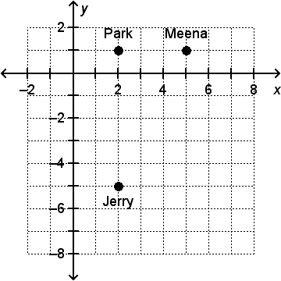

5. Point A is located at (3, 1), point B is located at (3, 4), and point C is located at (3, 1) on a coordinate plane.
a. What is the distance between points A and B?

b. What is the distance between points A and C?

6. Ravel wants to build a fence around his garden. The shape of his garden is shown on the coordinate plane, where each unit represents 1 foot. Use absolute values to find the length of each section of fence. How many feet of fence does Ravel need? Show your work.
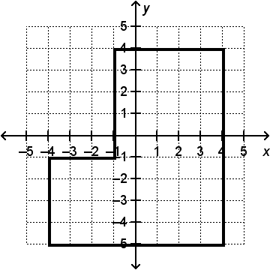

7. Jamie’s house is in the center of town, at point (0, 0). He is doing some errands in town and stops at the other four labeled points on the coordinate plane. One unit on the coordinate plane represents
1 block. He travels 4 blocks to his first stop. His second stop is 7 blocks from
his first stop. He can only travel on the sidewalks, which are represented by the grid lines.
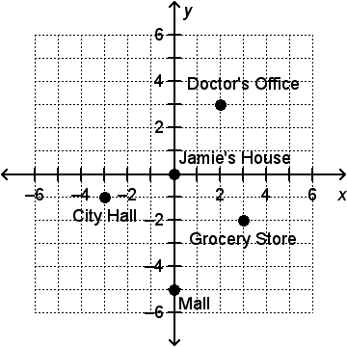
a. Where did Jamie go first?
List all possible answers. Justify
your answers.

b. Where did Jamie go second?
List all possible answers. Justify
your answers.

