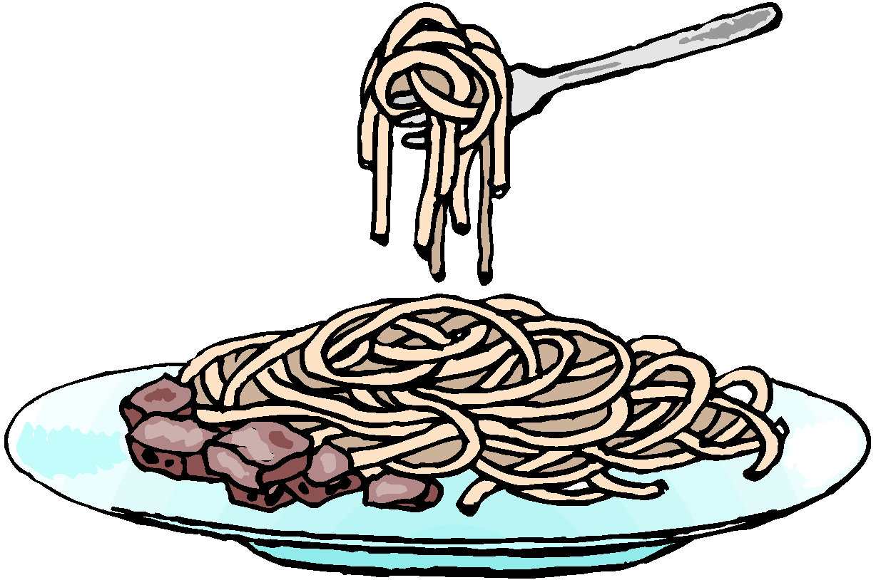
Missy Mix-It’s Famous Spaghetti and Meatball Recipe
10 Servings
60 minutes

3 tablespoons olive oil 1 dried bay leaf
¾ cup chopped onion Salt & pepper to taste
4 cloves garlic, minced 1 pound ground beef
2(16oz) cans crushed tomatoes ½ cup Italian seasoned bread crumbs
3 (6oz) cans tomato paste ¼ cup chopped fresh parsley
1 cup water ½ cup grated Parmesan cheese
½ cup sugar 1 (16oz) package uncooked spaghetti
¼ cup chopped fresh oregano, divided

Real Spaghetti and Meatball Recipe
6 Servings
120 minutes
1 tbsp. olive oil
1 cup onion
1 ½ tsp. garlic
½ cup red wine
1 (28oz) can crushed tomato
1 tbsp. parsley
1 ½ tsp. salt
½ tsp. pepper
1 ½ lb. spaghetti
½ lb. ground veal
½ lb. ground pork
1 lb. beef
1 cup bread crumbs (fresh)
¼ cup bread crumbs (dried)
2 tbsp. parsley
½ tsp. black pepper
¼ tsp. nutmeg
1 egg

Mom’s Spaghetti and Meatball Recipe
4 Servings
35 minutes
2 tbsp. olive oil
1 cup beef stock
1 (28oz) can crushed tomato
Parsley
10 basil leaves
1½ lb. sirloin
2 tsp. Worcestershire sauce
½ cup bread crumbs (dried)
1 egg
¼ cup parmesan cheese
2 garlic cloves
½ tsp. crushed red pepper flakes
4 garlic cloves
1 small onion

Bubba’s Spaghetti and Meatball Recipe
5 Servings
90 minutes
½ lb. mozzarella
1 lb. spaghetti
½ cup oil
1 onion
3 garlic cloves
2 (28-oz) can whole peeled San Marzano tomatoes
Salt
¼ cup basil leaves
1 onion
2 Garlic cloves
2 tbsp. parsley
1 cup milk
4 thick bread slices
1 ½ lb. beef
1 ½ lb. pork
1 egg
½ cup parmesan cheese

Mac’s Spaghetti and Meatball Recipe
6 Servings
75 minutes
¼ cup basil
½ lb. pork
½ lb. veal
½ lb. beef
2 eggs
¼ cup parmesan cheese
4 garlic cloves
¼ cup bread crumbs
¼ cup parsley
1 cup oil
1 lb. spaghetti
2 tbsp. oil
1 large Spanish onion
4 garlic cloves
1 bay leaf
2 (28oz) cans plum tomatoes
1 (16ox) can crushed tomatoes
Parsley
1 cubano chile pepper
Salt
Pepper

